**Program 1**

**Develop a Java program that prints all real solutions to the quadratic equation ax2 +bx+c = 0.**

**Read in a, b, c and use the quadratic formula. If the discriminate b2-4ac is negative, display a**

**message stating that there are no real solutions.**

import java.util.Scanner;

class equation

{

public static void main(String args[])

{

Scanner sc=new Scanner(System.in);

double a,b,c,r1,r2,d;

System.out.println("Enter the values of a,b,c");

a=sc.nextDouble();

b=sc.nextDouble();

c=sc.nextDouble();

d=(b*b)-(4*a*c);

if(d<0)

System.out.println("No real roots for the given quadratic equation");

else if(d>=0)

{

r1=(-b+(Math.sqrt(d)))/(2*a);

r2=(-b-(Math.sqrt(d)))/(2*a);

if(d==0)

{

System.out.println("Roots are real and equal");

System.out.printf("The roots are: %.2f and %.2f",r1,r2);

}

else

{

System.out.println("Roots are real and unequal");

System.out.printf("The roots are: %.2f and %.2f",r1,r2);

}

}

}

}

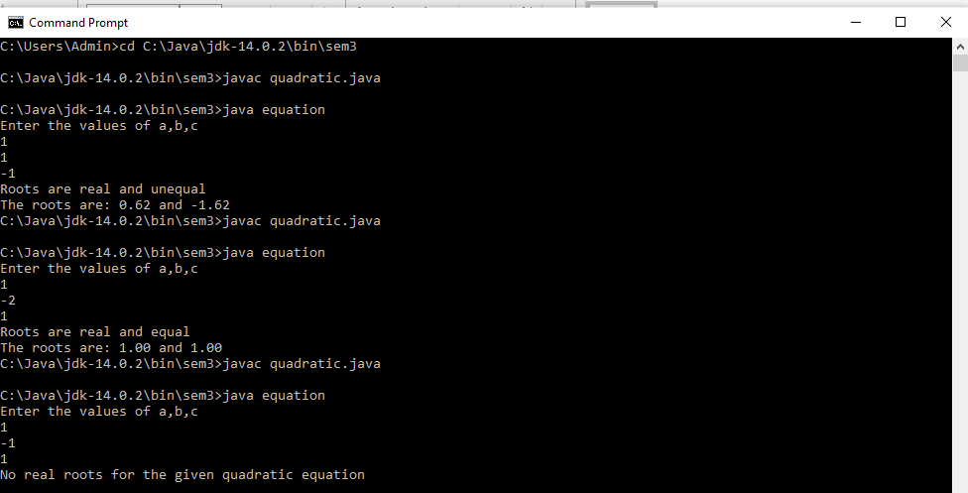

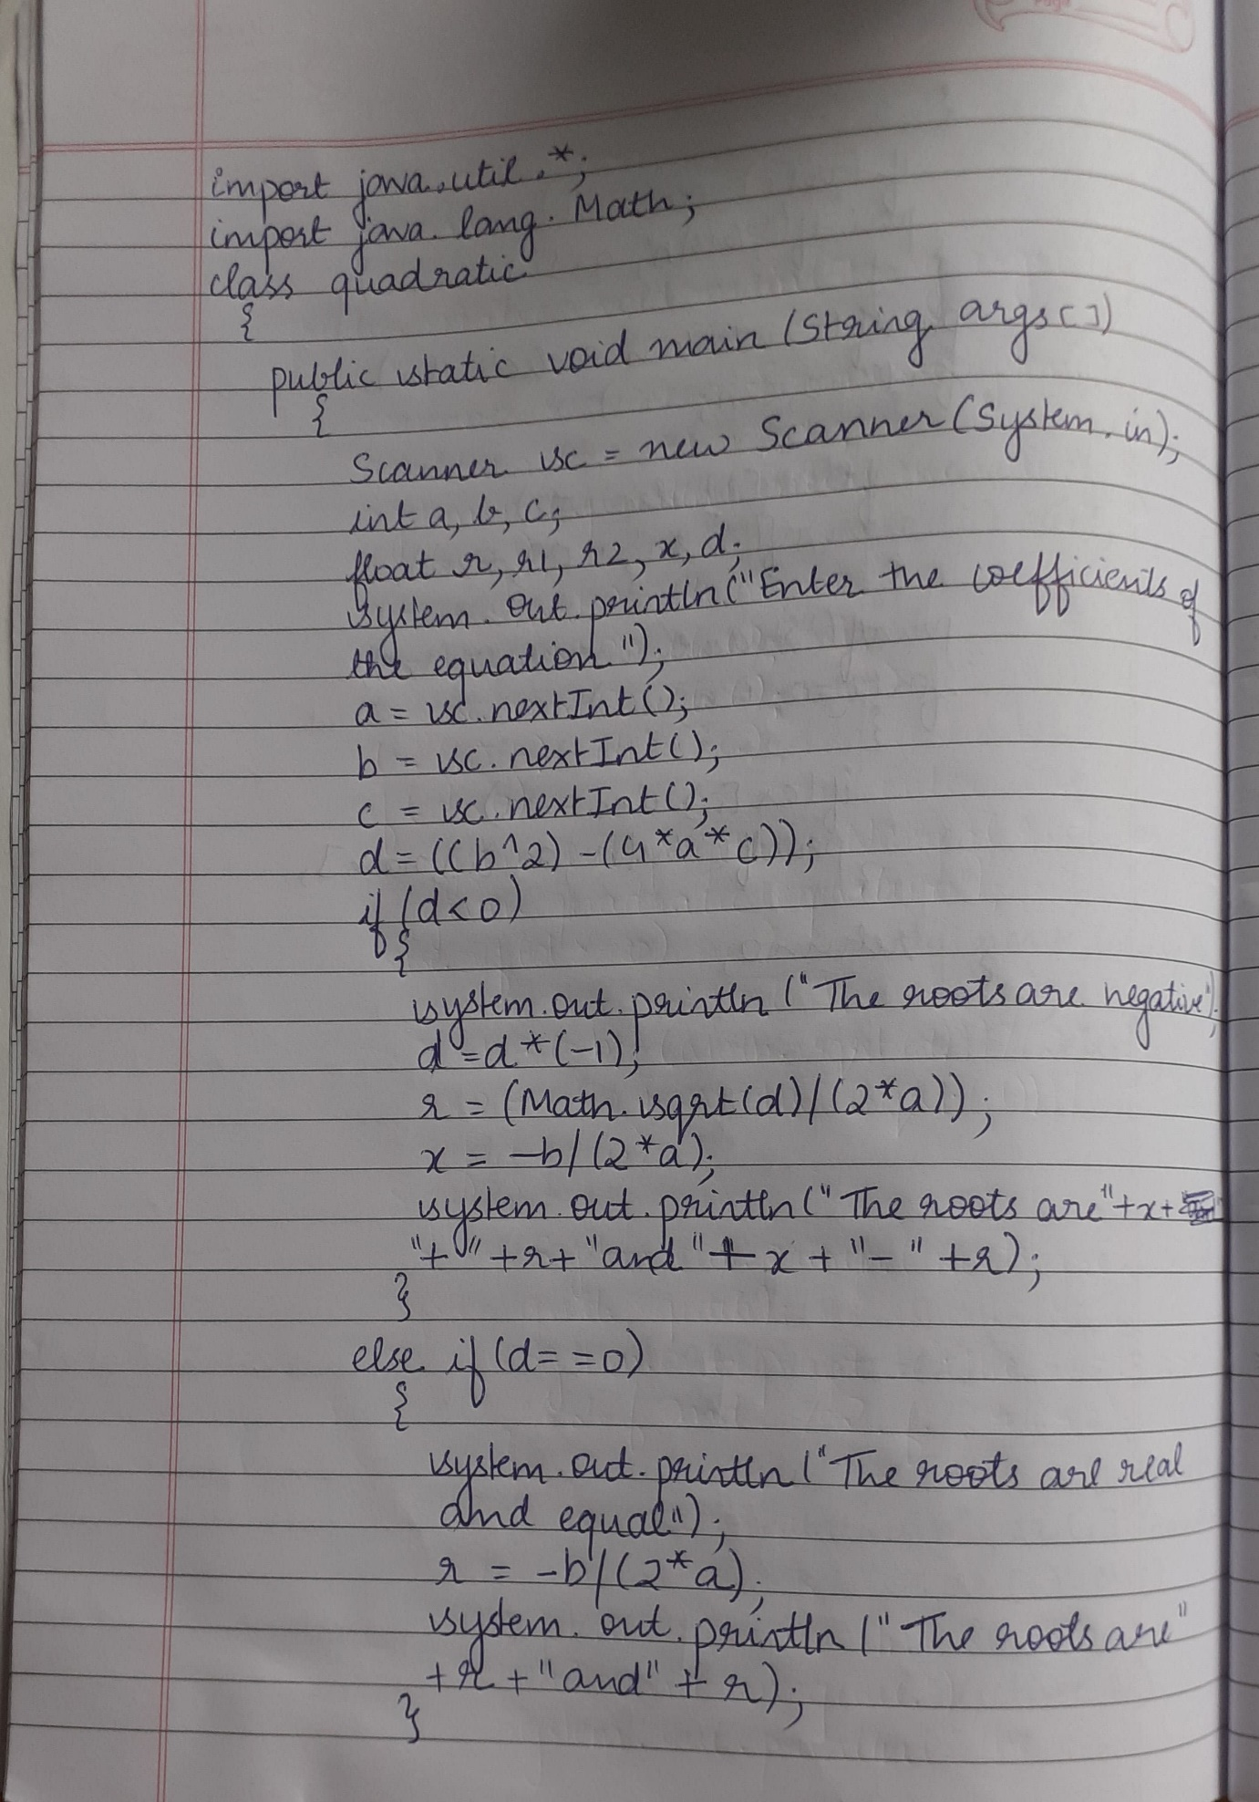

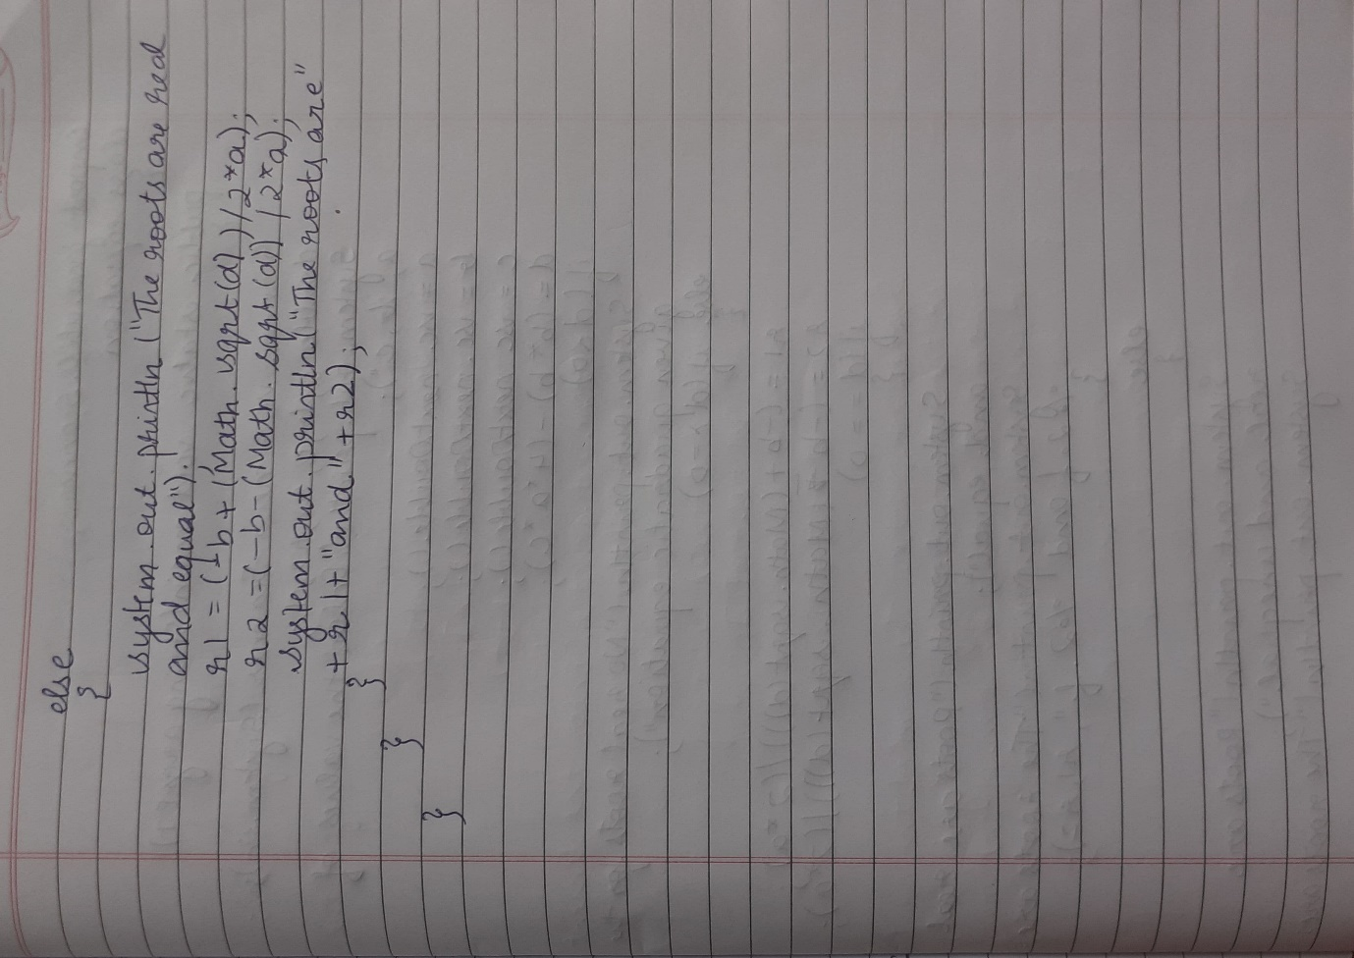

**Program 2**

**Develop a Java program to create a class Student with members usn, name, an array**

**credits and an array marks. Include methods to accept and display details and a method to**

**calculate SGPA of a student.**

import java.util.Scanner;

class Student

{

String usn,name;

int credits[];

float marks[];

int n;

float tot=0;

Student()

{

Scanner sc=new Scanner(System.in);

System.out.println("Enter the number of subjects");

n=sc.nextInt();

credits=new int[n];

marks=new float[n];

usn="";

name="";

}

void Accept()

{

Scanner sc=new Scanner(System.in);

System.out.println("Enter your USN and Name");

usn=sc.nextLine();

name=sc.nextLine();

System.out.println("Enter credits and marks for each subject");

for(int i=0;i<n;i++)

{

credits[i]=sc.nextInt();

marks[i]=sc.nextFloat();

}

}

void Calculate()

{

int s=0;

int m=0;

float a=0;

for(int i=0;i<n;i++)

{

if(marks[i]>=90)

m=10;

else if( marks[i]>=80)

m=9;

else if( marks[i]>=70)

m=8;

else if( marks[i]>=60)

m=7;

else if( marks[i]>=50)

m=6;

else if( marks[i]>=40)

m=4;

else if(marks[i]<40)

m=0;

s=s+credits[i];

a=a+(credits[i]*m);

}

tot=a/s;

}

void Display()

{

System.out.println("The details of the student");

System.out.println("USN:"+usn+" Name:"+name);

System.out.println("Credits and Marks");

for(int i=0;i<n;i++)

{

System.out.println(credits[i]+" "+marks[i]);

}

System.out.printf("SGPA %.2f",tot);

}

}

class StudentMain

{

public static void main(String args[])

{

Student s1=new Student();

s1.Accept();

s1.Calculate();

s1.Display();

}

}

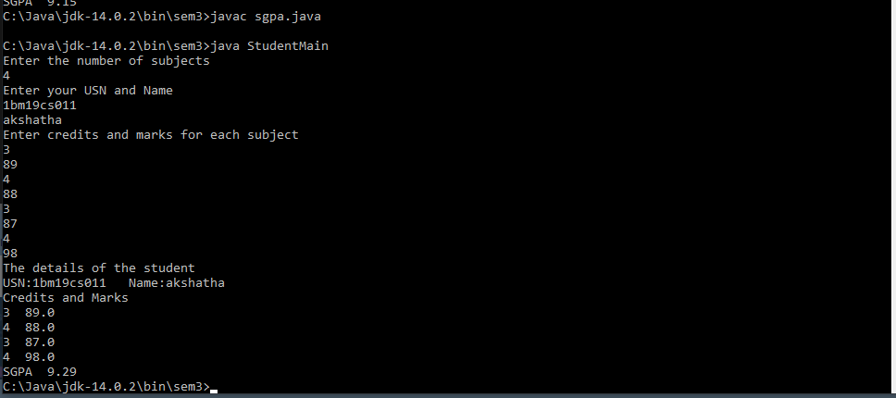

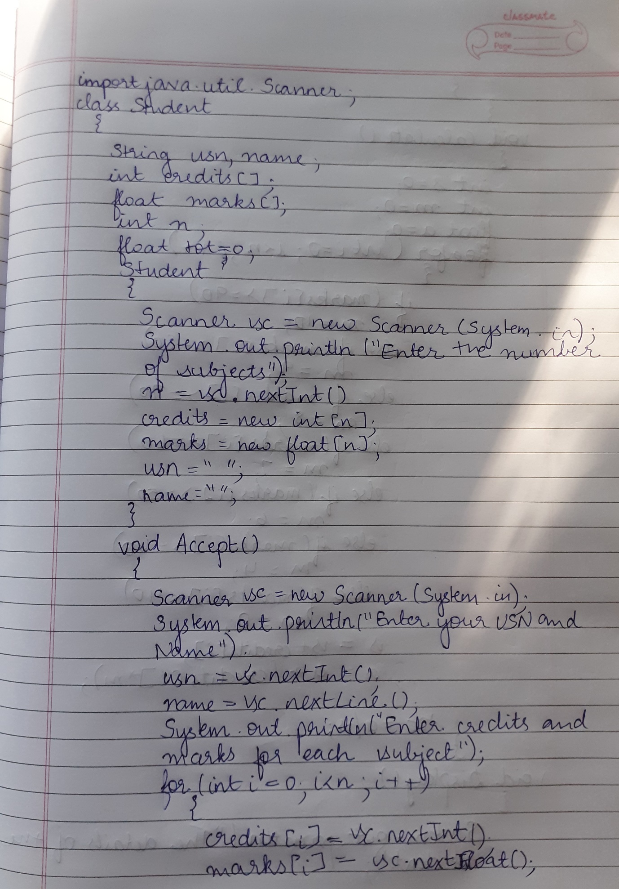

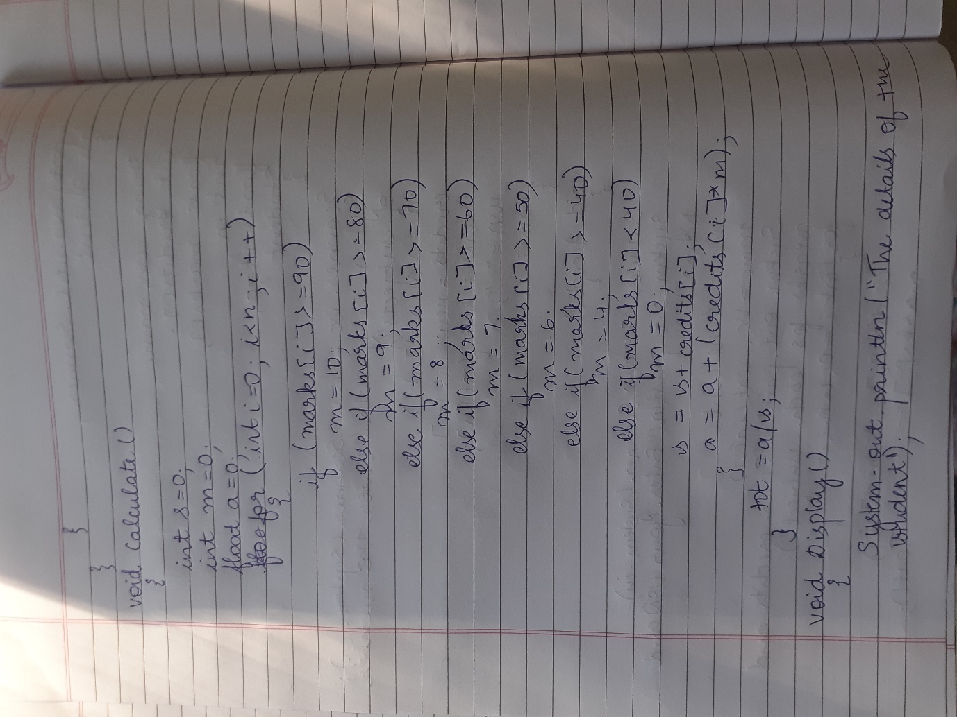

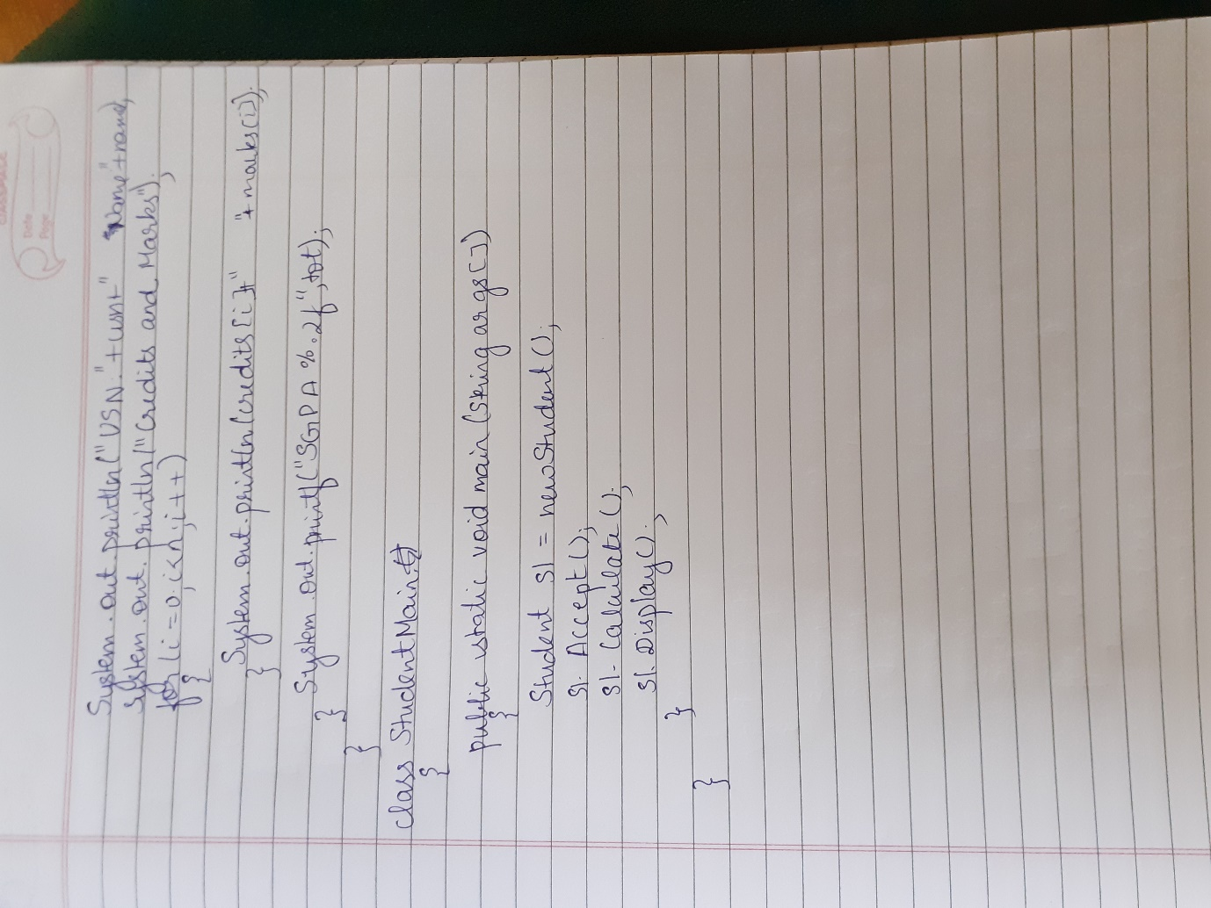

**Program 3**

**Create a class Book which contains four members: name, author, price, num_pages. Include a constructor to set the values for the members. Include methods to set and get the details of the objects. Include a toString( ) method that could display the complete details of the book. Develop a Java program to create n book objects.**

import java.util.Scanner;

class Book

{

String name,author;

int pages;

float price;

Book()

{

name="";

author="";

pages=0;

price=0.0f;

}

void Accept()

{

Scanner sc=new Scanner(System.in);

System.out.println("Enter the name of the book");

name=sc.nextLine();

System.out.println("Enter the author of the book");

author=sc.nextLine();

System.out.println("Enter the price of the book");

price=sc.nextFloat();

System.out.println("Enter the total number of pages of the book");

pages=sc.nextInt();

}

public String toString()

{

return("Name of the book: "+name+"\n Author: "+author+"\n Price: "+price+"\n Pages: "+pages);

}

}

class BookMain

{

public static void main(String args[])

{

int n;

Scanner sc=new Scanner(System.in);

System.out.println("Enter the number of books");

n=sc.nextInt();

Book b[]=new Book[n];

for(int i=0;i<n;i++)

{

b[i]=new Book();

b[i].Accept();

}

for(int i=0;i<n;i++)

System.out.println(b[i]);

}

}

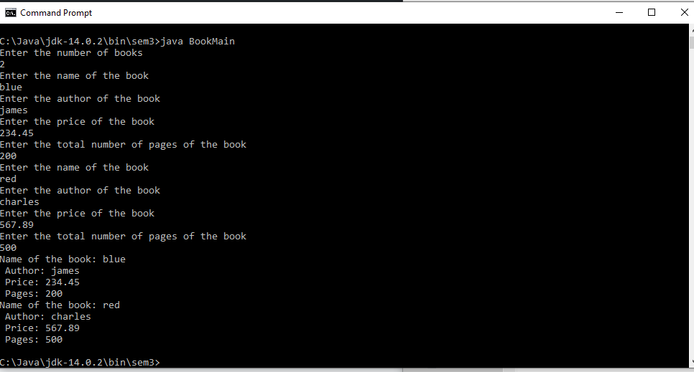

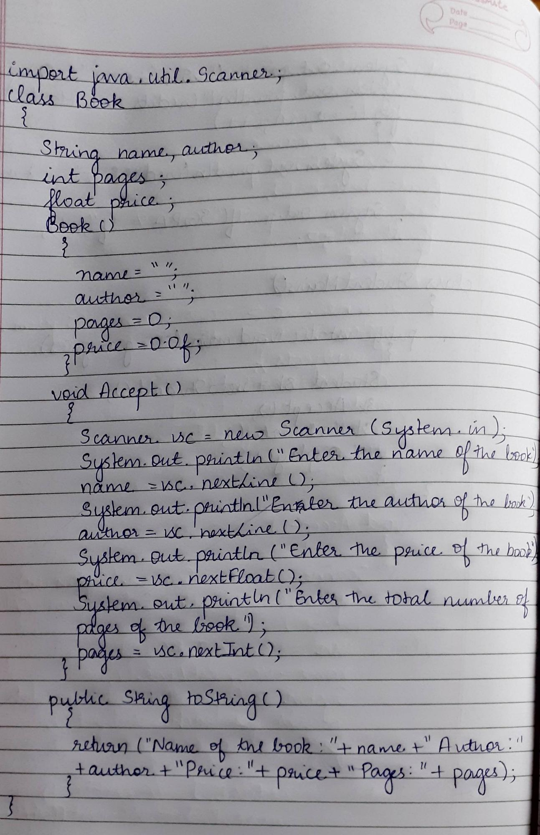

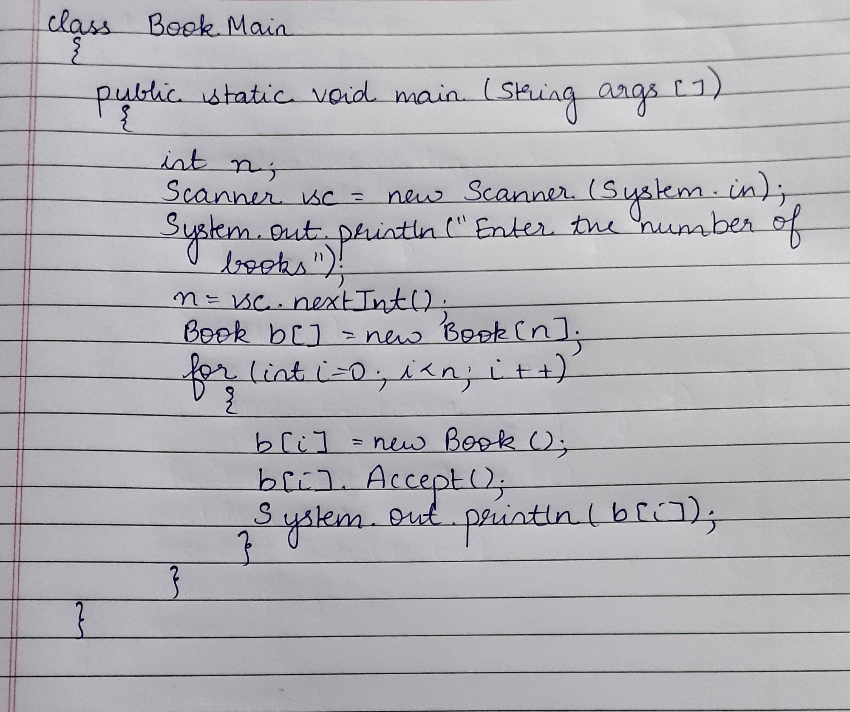

**Program 4**

**Develop a Java program to create an abstract class named Shape that contains two integers and**

**an empty method named printArea( ). Provide three classes named Rectangle, Triangle and**

**Circle such that each one of the classes extends the class Shape. Each one of the classes contain**

**only the method printArea( ) that prints the area of the given shape.**

import java.util.Scanner;

abstract class Shape

{

int a1,a2;

Scanner sc = new Scanner(System.in);

abstract void printArea();

}

class Rectangle extends Shape

{

void printArea()

{

System.out.println("Enter length and breadth of Rectangle: ");

a1 = sc.nextInt();

a2 = sc.nextInt();

System.out.println("The area of Rectangle is: "+a1*a2);

}

}

class Triangle extends Shape

{

void printArea()

{

System.out.println("Enter base and height of Triangle: ");

a1 = sc.nextInt();

a2= sc.nextInt();

System.out.println("The area of Triangle is: "+(a1*a2)/2f);

}

}

class Circle extends Shape

{

void printArea()

{

System.out.println("Enter radius of Circle: ");

a1 = sc.nextInt();

System.out.println("The area of Circle is: " +a1*a1*3.14f);

}

}

class MainShape

{

public static void main(String args[])

{

Rectangle r = new Rectangle();

r.printArea();

Triangle t = new Triangle();

t.printArea();

Circle c = new Circle();

c.printArea();

}

}

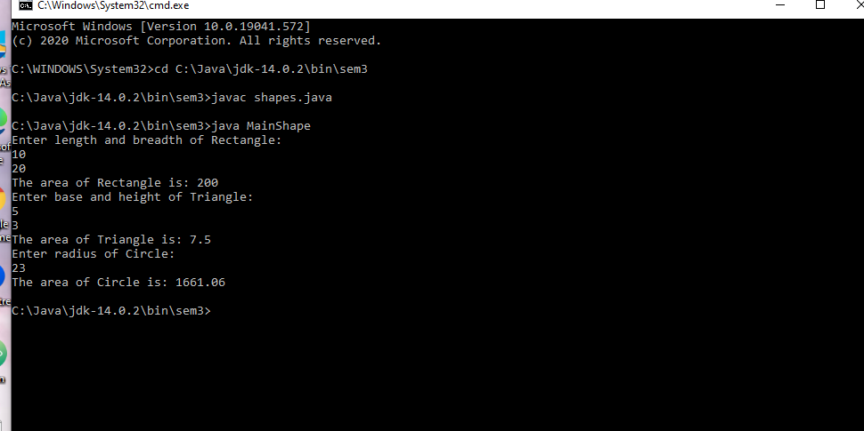

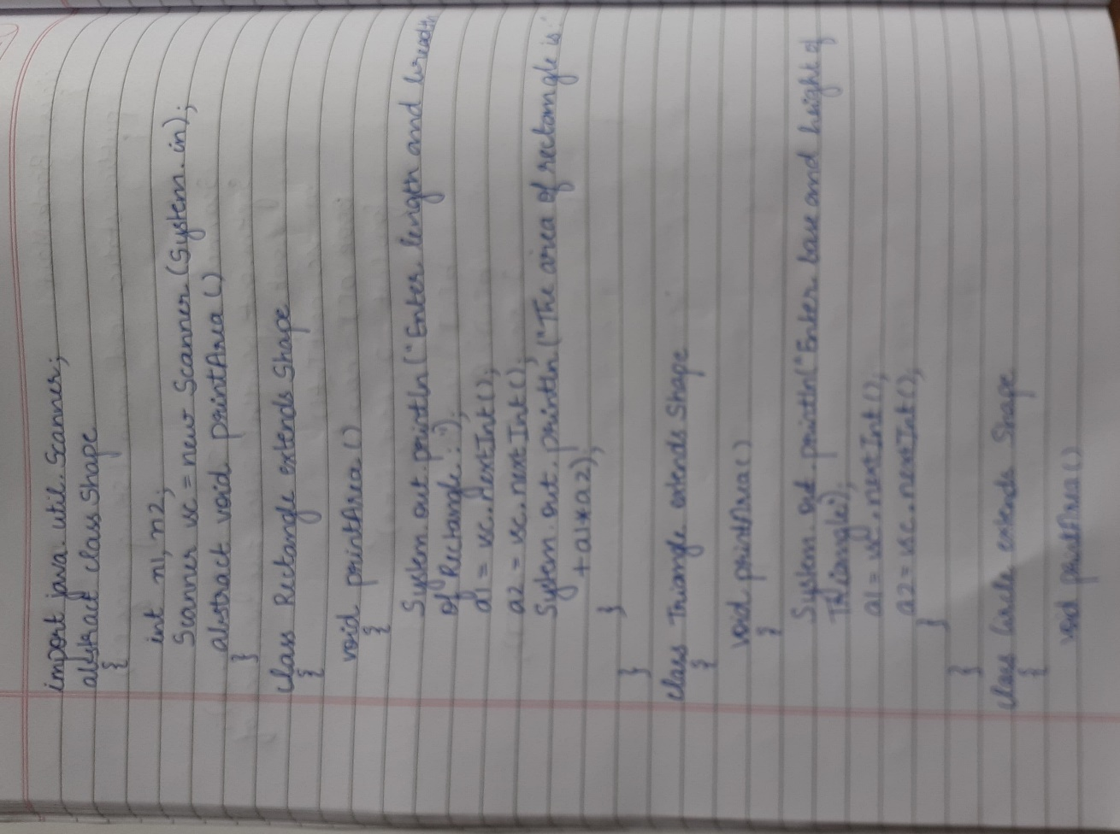

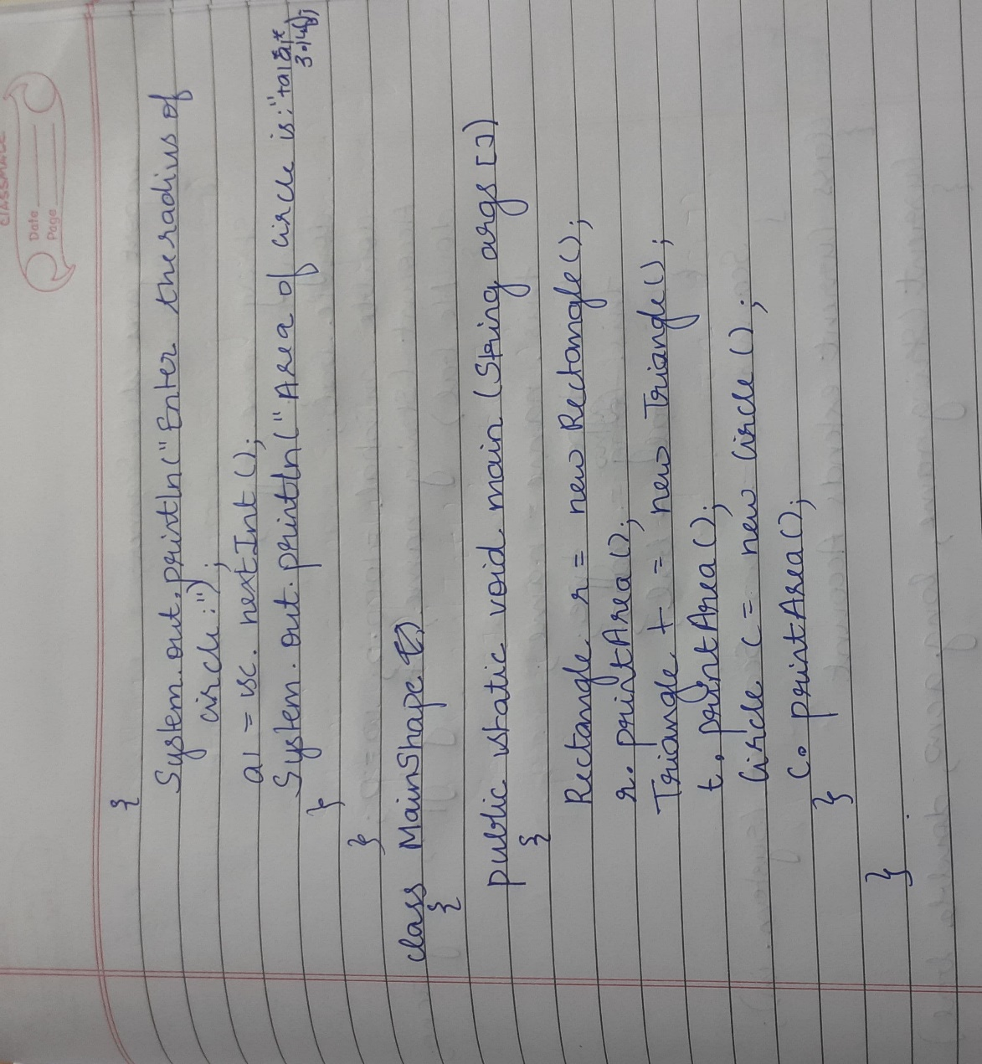

**Program 5**

**Develop a Java program to create a class Bank that maintains two kinds of account for its**

**customers, one called savings account and the other current account. The savings account**

**provides compound interest and withdrawal facilities but no cheque book facility. The current**

**account provides cheque book facility but no interest. Current account holders should also**

**maintain a minimum balance and if the balance falls below this level, a service charge is**

**imposed. Create a class Account that stores customer name, account number and type of**

**account. From this derive the classes Curr-acct and Sav-acct to make them more specific to**

**their requirements. Include the necessary methods in order to achieve the following tasks: •**

**Accept deposit from customer and update the balance. • Display the balance. • Compute and**

**deposit interest • Permit withdrawal and update the balance • Check for the minimum balance,**

**impose penalty if necessary and update the balance**

import java.util.Scanner;

class Account

{

String name,type;

long acno;

double bal;

double minbal=1000.0;

double w=0;

Account(String name,String type,long acno,double bal)

{

this.name=name;

this.type=type;

this.acno=acno;

this.bal=bal;

}

Scanner sc=new Scanner(System.in);

}

class Current extends Account

{

Current (String name,long acno,double bal)

{

super(name,"Current",acno,bal);

}

void Withdraw()

{

System.out.println("Enter the amount you want to withdraw");

w=sc.nextDouble();

bal=bal-w;

Balance();

}

void Deposit()

{

System.out.println("Enter the amount you want to deposit");

w=sc.nextDouble();

bal=bal+w;

}

void Balance()

{

if (bal<minbal)

{

System.out.println("Insufficient balance ,penalty will be imposed");

bal=bal*0.3;

}

}

void Display()

{

System.out.println("Name"+name+"\n Account number"+acno+"\n Type of account"+type+"\nBalance"+bal);

}

}

class Savings extends Account

{

Savings (String name,long acno,double bal)

{

super(name,"Savings",acno,bal);

}

void Withdraw()

{

System.out.println("Enter the amount you want to withdraw");

w=sc.nextDouble();

bal=bal-w;

}

void Deposit()

{

System.out.println("Enter the amount you want to deposit");

w=sc.nextDouble();

bal=bal+w;

Calculate();

}

void Calculate()

{

int t=2, R=55;

bal=bal+bal*(Math.pow((1+(R/100)), t));

}

void Display()

{

System.out.println("Name"+name+"\n Account number"+acno+"\n Type of account"+type+"\nBalance"+bal);

}

}

class MainAccount

{

public static void main(String args[])

{

Scanner sc=new Scanner(System.in);

System.out.println("Enter your name");

String name=sc.nextLine();

System.out.println("Enter your account number");

long acno=sc.nextLong();

System.out.println("Enter your account balance");

float bal=sc.nextFloat();

System.out.println("Type of account:\n 1.Current account\n 2.Savings account\n 3.Exit");

int o=sc.nextInt();

if(o==1)

{

Current c = new Current(name,acno,bal);

while(true)

{

System.out.println("1.Deposit\n2.Withdraw Amount\n3.Display\n4.Exit");

int ch = sc.nextInt();

switch (ch)

{

case 1:

c.Deposit();

break;

case 2:

c.Withdraw();

break;

case 3:

c.Display();

case 4:

System.exit(0);

default:

System.out.println("Invalid choice");

}

}

}

else if(o==2)

{

Savings s = new Savings(name,acno,bal);

while(true)

{

System.out.println("1.Deposit\n2.Withdraw Amount\n3.Display\n4.Exit");

int ch = sc.nextInt();

switch (ch)

{

case 1:

s.Deposit();

break;

case 2:

s.Withdraw();

break;

case 3:

s.Display();

case 4:

System.exit(0);

default:

System.out.println("Invalid choice");

}

}

}

else if(o==3)

System.exit(0);

else

System.out.println("Invalid choice");

}

}

